A one pager to remind staff and students exactly what the term literacy means. Blow this up and print in colour on an A3 document and display in the staffroom, the foyer (if you can) and in the library.

<Name of School goes here>
promotes literacy for everyone

Sharing
Learning

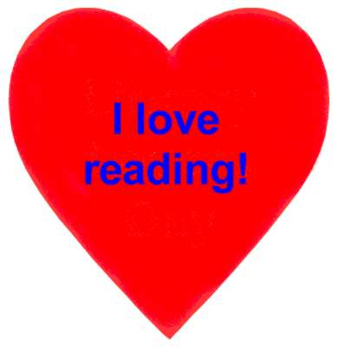
Literacy is: "... the integration of listening, speaking, reading, writing and critical thinking. It includes a cultural knowledge which enables a speaker, writer or reader to recognise and use language appropriate to different social situations. For an advanced technological society such as Australia, the goal is an active literacy which allows people to use language to enhance their capacity to think, create and question, in order to participate effectively in society."
The National Secretariat for the
International Year of Literacy, 1990
Literacy is:
... the making of meaning and its clear communication to others. Truly literate people not only read and write, but regularly do so in order to sort out their ideas and put them in words, to fit them together and test hypotheses - ie. to make sense and meaning out of our world. Truly literate people acknowledge that they need to write things down, to talk them out, to read widely, to listen critically and to respond articulately. Truly literate people are thinkers and learners."
Brown & Mathie, 1990
Literacy is:
"... the foundation of effective citizenship, human communication and social integration in a literate society. Therefore it is important to foster the lifetime habit of purposeful and critical reading for information, education and recreation. Literacy is the foundation of learning in all areas of the curriculum."
Holdaway, 1979.
Collaboration
Cooperation

