IASL/SLAQ Conference in Brisbane 2010

Diversity, Challenge Resilience School Libraries in action

Inspiring and innovative teacher-librarians, challenging and provocative keynotes, collegial and entertaining activities were all a part of the IASL/SLAQ Conference in Brisbane this year. Thanks to the WALSA committee for providing the lucky draw at the City Roadshow, I was privileged to experience the wide range of information literacy, literature/ reading sessions, information competency strategies, cybersafety presentations, author talks and social events at the conference. As is always the case, choosing which sessions to attend is often the hardest decision to make.
Each keynote address highlighted the challenges we face in our roles as Teacher-Librarians. The Governor of Queensland, Penelope Wensley AO opened the Conference by encouraged us to embrace with enthusiasm and energy the significant changes in our environment by discussing the relevance to our real world. The following speaker urged us to look back on the success of resourceful Teacher-librarian partnerships and advised us that to change the future we must intervene in the present by re-conceptualizing library services. Dr Michael Hough Professorial Fellow at Uni of Woollongong encouraged us to make libraries I-centres in our schools, to counsel our executives about scrutiny of performance and be aware of risk management as we could be held accountable for value adding. He also highlighted the fact that our kids are confident but careless. Therefore, we should be aware of the moral and ethical growth required for these students to cope in the real world. As an interested futurist, it was recommended that we use data to support our case for teacher-librarians. Dr Nancy Everhart from Florida State University reminded all Teacher–librarians that in order to be legitimate, we have to do what we say we do! A school library should give access to information 24/7, T-L s need to work collaboratively with teachers by working from their curriculum needs, be involved in assessing students’ learning and teach alongside subject teachers as well as offering leadership in technology. Dr Erica McWilliam High spoke about standards in her keynote. She pointed out the generation gap concepts that we need to understand to prepare our students for the world as they see it. For example, learning for them is ‘Just in time’ and ‘Just enough’, along with a choice of when and how they learn.

Information Literacy was a key concept addressed by a variety of presenters. The ‘Plato Project’ at William Clarke College was an innovative information skills continuum presented by John Stanton, which has evolved over 7 years. He uses Bloom/Gardner Matrix to introduce students to critical thinking skills as they learn about their own learning and differentiation. He focused on ’essential questions’ and discovered that for these projects, the more abstract concepts were more successful in developing students’ critical thinking and metacognition. Following this project, each learning area has been challenged to identify the fundamental skills and knowledge that a student should attain in that learning area by the time they leave school to cope successfully in the real world. I feel this could be an interesting exercise to explore in our school. Information Literacy competence was also a prominent theme at Brisbane Girls Grammar where their use of notebooks enables learning to be seamless and continual with much learning occurring outside the classroom when the students are in-charge of their learning. To develop competencies using information, the staff must know how to use the tools and software in their teaching. They used a wide range of Web 2.0 tools and software including free programs such as Jing, Wink, Moodle, Ziptales, Onenote, Turnitin and ebooks. Tutorials were used to assist competency with these tools and made available on the library webpage. The library had a charging centre for the girl’s laptops, and everyone had an SD card to save their work, so there was no excuse for not being prepared. The library usage had not been affected by the one-to-one laptop change.
With the chance to see what our New Zealand cousins were doing, I chose the session on Inquiry Learning with Senior School Students by Jill Stotter and Kirsty Gillon. A new curriculum has been introduced but with no PD, practice is slow to change, if at all. However, Jill and the T-L initiated a trial to teach Year 11 History using an inquiry method. The focus was on researching one curriculum exam question that would be used to teach the other students. Background was provided, students were explicitly taught identified research skills and then guided to complete their part of the content via their question. It was interesting to hear how difficult the history teacher found it to step back from being ‘the sage on the stage’ and guide the students to learn independently. However, she appreciated the changed learning whilst emphasizing the need to specifically teach research skills and reinforce their application before the students reach year 11.
The importance of Web 2.0 tools was a dominant theme but it was recognized that many students still need significant instruction in basic strategies to be successful researchers and ethical users of information in the future. Even in one of the most technologically advanced schools, they have seen the need for a series of sessions for all Year 11 and 12 students called ‘Calibrating the learning engine’. They included Deep Research, designed to assist students deciding on the best search engines, meta search engines and evaluation of the website information; Efficient Search Strategies, to formulate search terms strategies and use metacognition to improve searching; Use of online databases; Use of Web 2.0 tools to assist organization and finally Digital Citizenship, to develop responsible and ethical citizens (including defamation and privacy.) Response from the boys was extremely positive and the program will be expanded.
Looking for inspiration for literature promotion prompted me to choose sessions on Literature Circles, Picture books and Portugal’s National Reading Program. The value of Literature Circles for boys was highlighted at Brisbane Grammar. As part of the Years 6 to 8 English Program for the semester, the Teacher-Librarian selects the novels and roles, the boys read to a set place and complete one role each week with some reflections being assessed. Habits of mind skills were taught to combat impulsivity, empathy and understanding and communicating with clarity. It was observed that the boys’ quality of discussion improved considerably over time and involvement in the literature circle program. A list of the novels used is available if anyone is interested. An enthusiastic T-L from Hong Kong shared her passion for picture books for older readers. I was familiar with most of the authors and titles and share her recognition of their value as literary texts. It was equally refreshing to see the National Reading Program’s successful development in Portugal where they worked in cluster regions and even had local businesses supporting the promotion of reading. The goal was to create a culture of reading for pleasure and reading as a central element in all curriculum areas. They have recognized that Teacher-librarians are an essential part of reading promotion and enjoyment by increasing numbers employed in schools.

Creative writing using technology provided more fascinating sessions, with one from a school and another from the author, Hazel Edwards. Digital stories and narrative writing using web tools with year 9 and 10 boys showed the quality of work that could be produced and exemplified the value of metacognition in the process of developing their work. Digi- stories usually contain a mixture of computer-based images, text, a recorded narration with video clips and/or music requiring quite sophisticated use of tools to produce a quality end product. There was obviously a lot of instruction in narrative techniques and background from a collaborative teacher and Teacher-Librarian. In Year 9 the boys chose their own topics, but in Year 10 the topic was ‘leadership’ which gave the boys a chance to explore the qualities of leaders. Very diverse aspects of this concept were chosen ranging from investigations of family members to well-know personalities. The samples of work displayed in the presentation were of an outstanding quality and the range of techniques employed impressive. The teachers commented on the development of a community of learners who learnt to speak to other and talk about being reflective. Hazel Edwards, one of our well-known authors spoke about her experience of co-authoring her latest book f2m. She explored the writing process she employed and her knowledge of transgender issues whilst also learning about Web 2.0 tools in communicating with Ryan, her co-author. She strongly recommended the use of blogs and other tools for promoting books to young readers and valued their use in connecting with our teenage readers.

Hazel Edwards and her Hippo at the session on Collaborating across new media and gender
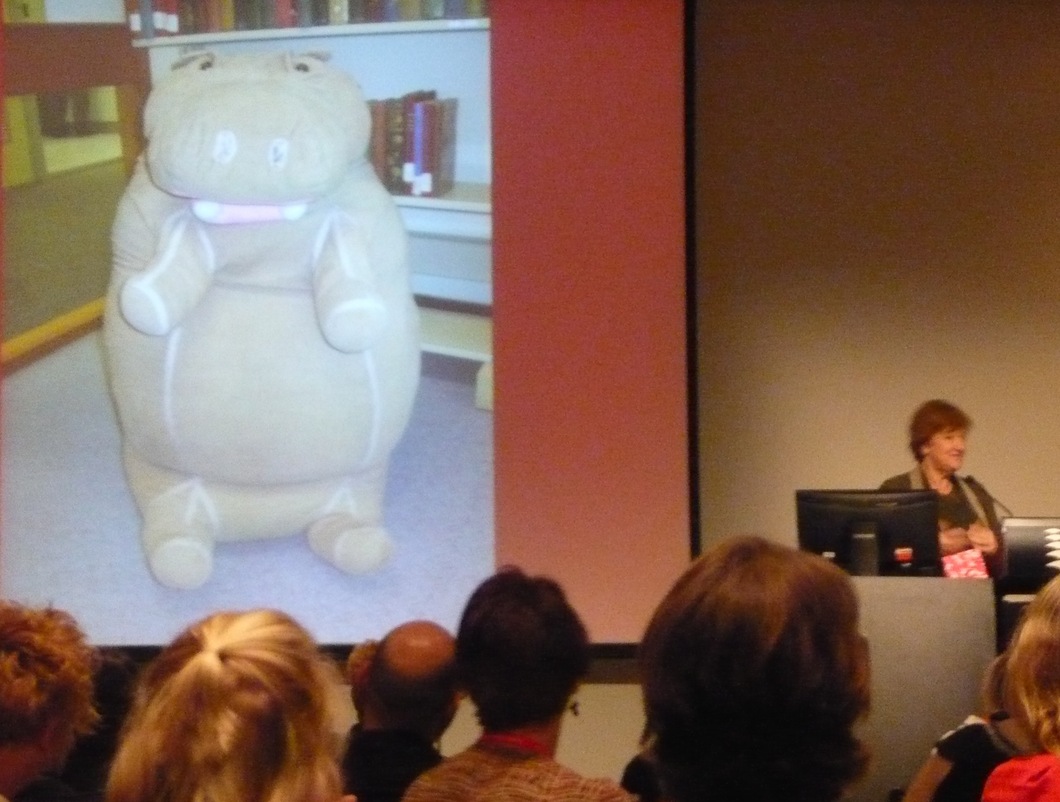
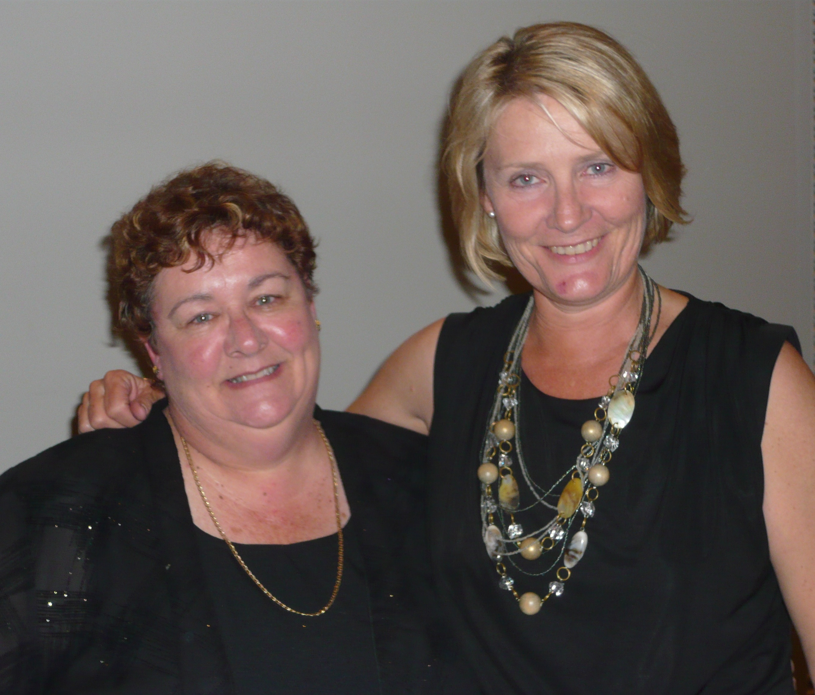
Barbara Combes and Mary Hookey
The Giggle It Project was another session of interest and was featured at the Trade Exhibit area. The Illustrators Café allowed us to see the artists in action.

Responsible learners and Cybersafety are vitally important issues. The Cybersafety Awareness session by Greg Gebhart was full-on, with some cautionary tales for us to consider especially in relation to the next generation of kids who have access to mobile internet access from a very early age. He highlighted the need for awareness of the immersion of our young people in social networking, the addictive nature of some gaming sites, sexting, online stranger danger, identity theft and cyber-bullying. He provided suggestions to support schools and parents to guide our children towards greater digital responsibility and safety. There is support available from the cybersafety website and are available to come out to schools but we need to book ahead.

Day 2 began with ‘Breakfast with the Authors’. A delightful range of stories from many authors including David McRobbie, Narelle Oliver, Michael Gerard Bauer, Hazel Edwards. John Danalis to name a few. With authors at every table and short presentations from the authors on interesting aspects of their writing, everyone thoroughly enjoyed the morning. Of particular interest was John Danalis showing us the possum cloak made especially for him after the return of the aboriginal relic to the tribe for burial. 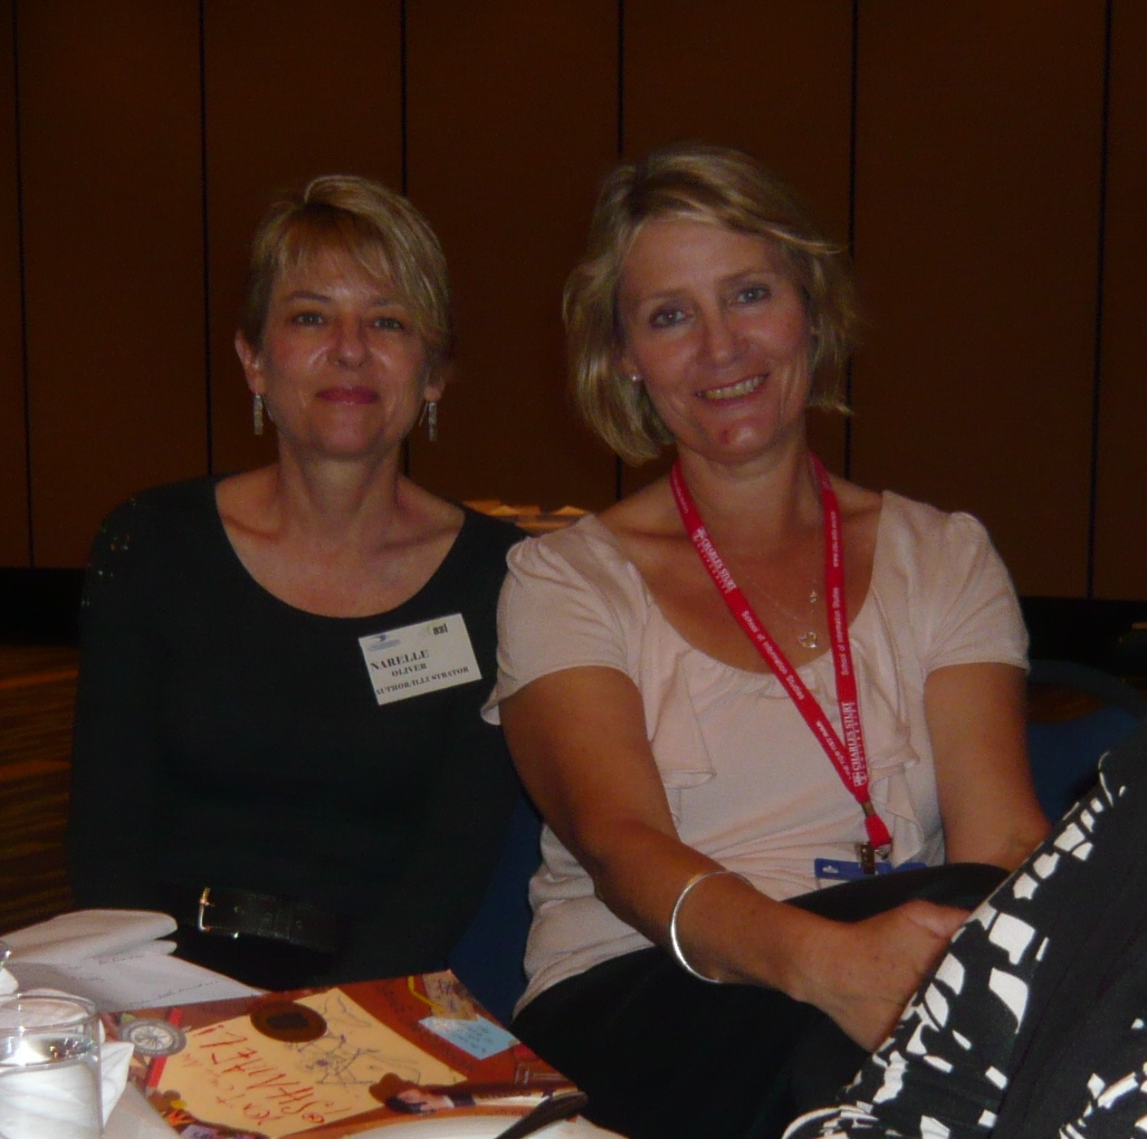
Narelle Oliver ( author) and Mary Hookey at the Breakfast

The dinner was another experience. During the meal, there was an auction of donated items to raise money to support and promote reading in third world countries. Countries from around the world including Africa, Jamaica, Austria, Russia and other places in between had representatives attending this conference giving the auctioneer a captive audience to coerce into bidding for the items to take home and treasure. He did an amazing job and raised $6000 that evening.
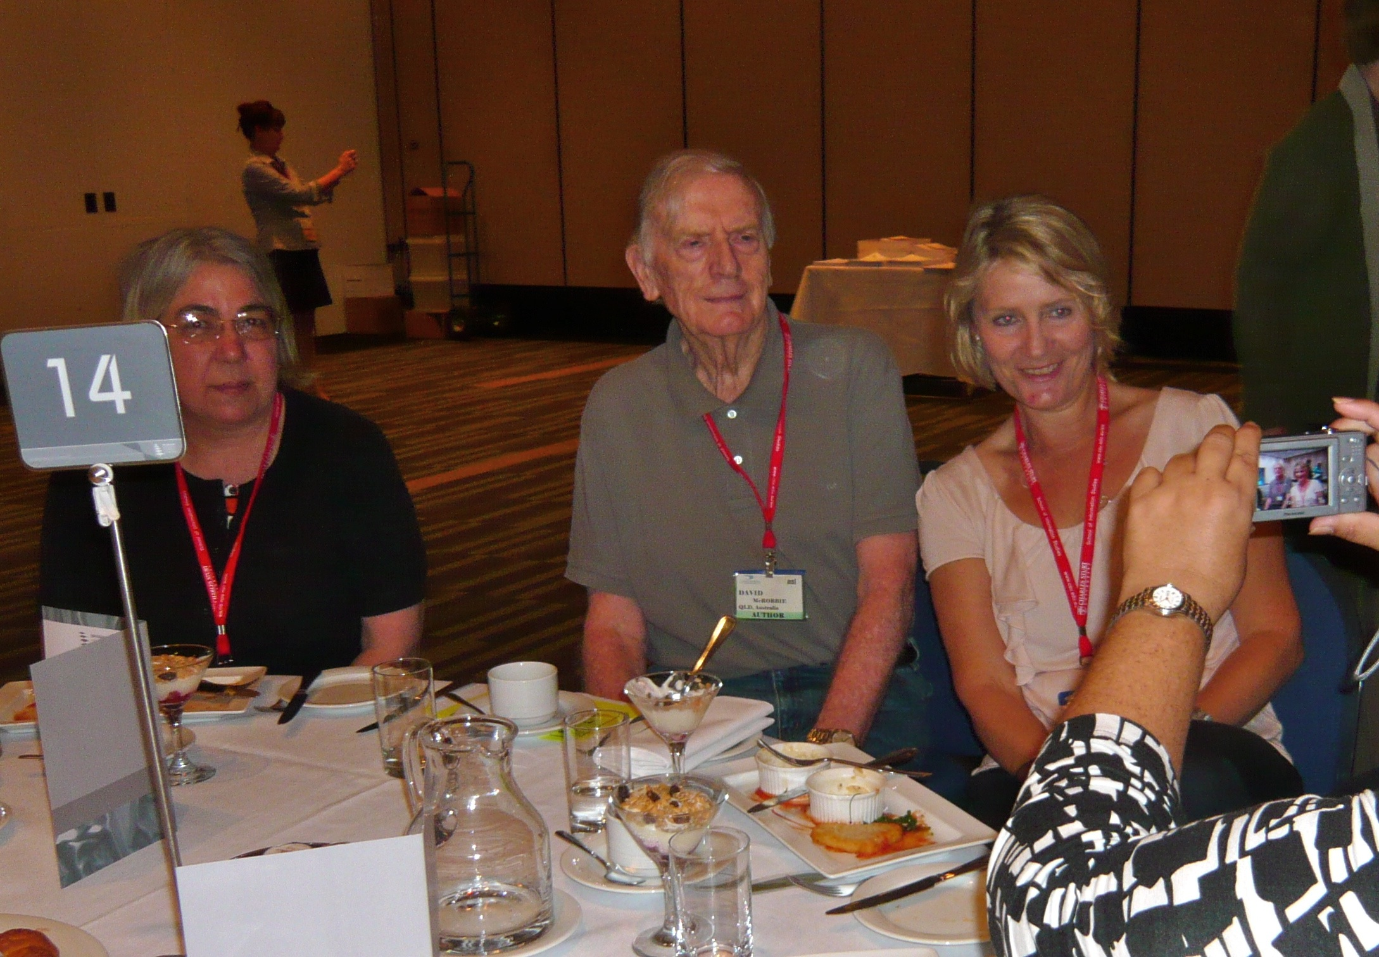
Sue Stopher, David Mc Robbie and Mary Hookey at the Breakfast.
Finally the last day began with the Keynote by John Marsden entertaining us with an impromptu activity where members of the audience enacted a dialogue without using any words with the letter ‘s’ when trying to buy and umbrella. This simple tasks could be used to help create stories. He provided other writing suggestions about the difference between plot driven novels and literature where character consciousness is a focus. To help others to write, his suggested looking at the power of nouns and verbs to transform simple writing to another level. We were treated to readings from his novels where he explored the symbols and figurative images used to unconsciously implant ideas in the reader’s mind. He also threw in the idea that weather is a common symbol used in fiction but in reality it effects everything and once the writer has determined what the weather is, the movements, behaviours, feelings and what happens can be developed. An interesting concept . The last aspect of the conference was the Author Panel Dscussion on the transition of books to movies/TV. All were pleased with the results and explored the differences in their works.
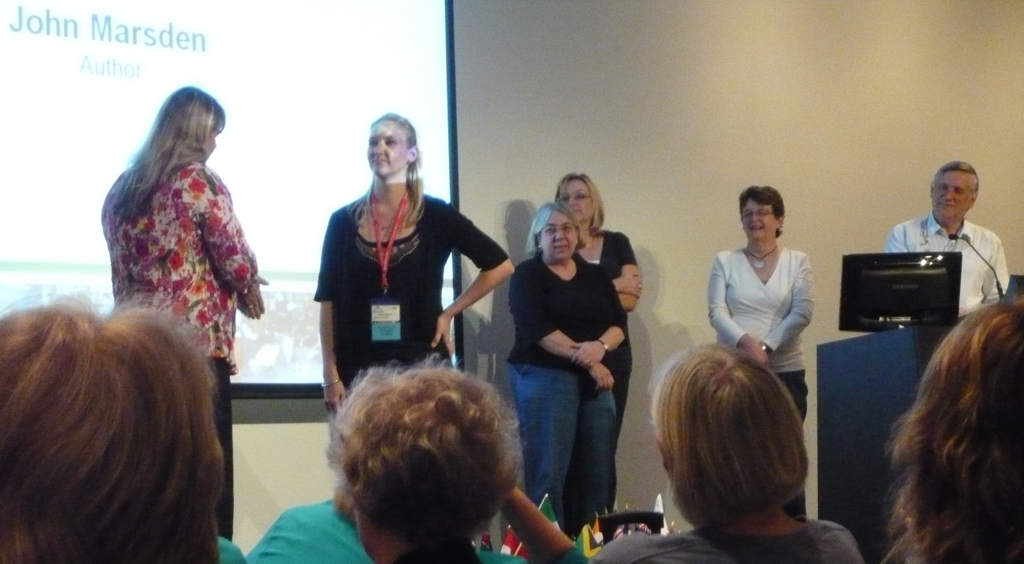
John Marsden and the “Umbrella dialogue”
Overall, the conference offered a wide selection of opportunities to enrich and inspire those who attended. If anyone is interested in further information on sessions, please contact me (jan.finning@det.wa.edu.au) and I will be happy to follow up where possible.

Next year’s ASLA conference will be in Sydney 2nd to 5th October 2011 with the theme of ‘Innovation, Integration, Instruction’.

Day 3 Keynote Dr Erica McWilliam High standards or a high standard of standardness?
As A futurist, she pointed out the generation gap concepts that we need to understand to prepare our students for the world as they see it. For example, learning is ‘Just in time and just enough, along with a choice of when and how they learn. We heard about the 16th and 17th Coffee ship where there was sharing of resources, brokering of new ideas and contacts around a round table.
Looking at how young people are engaging online. value-adding capacities in on-line networks; Usefully ignorant, seriously playful; epistemologically agile; team oriented; ideas broker ad translator; technologically savvy
Agile with knowledge being able to move across knowledge horizons and mix and match
Knowing what to do when they don’t know what to do. 21st century work is harder , the complexity of work has changed and Professional risk management is necessary.

2. Brisbane Grammar use of netbooks enabling learning to be seamless, continual with most occurring outside the classroom when they are in-charge. develops competencies using info but it means staff must how to use the tools and software in their teaching. Examples of tools - Ziptales, Downloading e-books jing or wink free web2.0 tools) to create tutorials, and library webpage in Moodle, Onenote charging centre in library for all notebooks all girls have sd cards use digitalstorytelling.coe.eh.edu. they used Turnitin before they submit essays
3. Digital storytelling in Brisbane Goys Grammar Using computers based tools to tell stories year 9 and 10 Boys. Digital stories focus on as specific topic and contain a particular point of view
Free image sites
Compile a list of copyright free sites for image sounds and effects
www.a1freesounds.com Create a task that exploited tablet tools and progresses early ICT journey
Experiment with multimodal and genre (poetry/ narrative/visual)
Unit on Leadership a very worthy project, I including metacognition
Lesson for teacher & TL
Shift away form traditional owner structure; expert voice also belongs with student and collegial sup[ort
make kids accountable
Community of learners, learn to speak to other and talk being reflective
Real task – real people & real stories dilution of networked isolation – more ‘real’ talk
4.
5. MLC libraries – a school library’s journal
Jane Viner Director and Amanda Lucas Assistant Director
Blogs Wikis and future

Visual Literacy using Picture books with older readers

John Marsdens key note

