The World Wide Web

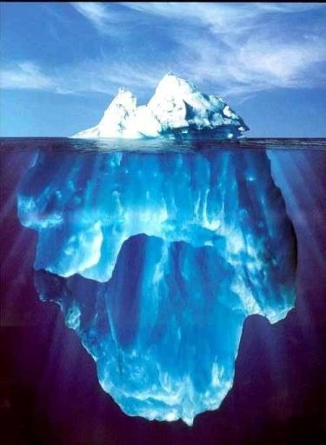

PUBLIC DOMAIN
THE PART OF THE WEB EVERYONE CAN ACCESS
7-10%

THE DEEP, HIDDEN

OR
INVISIBLE WEB
THE PART OF THE WEB SEARCH ENGINES LIKE GOOGLE DON’T FIND
90%+
THE INTERNET = the sky + the ocean + the iceberg

The World Wide Web is NOT the Internet.
The Web is one part of the Internet.
Internet2? (yes!)… Internet3? (maybe!)

