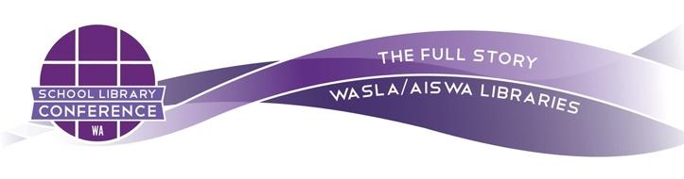
Kennedy Baptist College
Farrington Rd, Murdoch
8 – 9 October 2021

School Library Conference (WA) 2021

Expressions of Interest – Breakout Session Presenter

Expressions of interest to run breakout sessions for this collaborative professional development day on Saturday 9 October 2021 are now open. Our conference theme is “The Full Story.”
The breakout session presentations should reflect the conference theme, however, any school library related topics that would be of interest to a diverse audience, would also be considered.

Complete this expression of interest form by COB Friday 23rd July, 2021.

Speakers should be aware of the following:

- Breakout session presentations are 30 mins duration plus 10 mins extra time allocated for Q&A
- One paragraph abstract should include relevant information that gives an overview of the topic
- Rooms will have a screen and data projector; you will need to provide a laptop. Any other AV requirements need to be advised
- Speakers who are successful in their submissions will be given half-price registration to the conference
- All submissions will be reviewed by the Conference Organising Committee and decisions will be communicated by Monday 16 August 2021
- Non-members of WASLA & AISWA Libraries are welcome to submit an EOI.

About our theme The Full Story
School libraries provide a healthy, safe atmosphere where diversity and individuality are respected and celebrated. Within the scope of our school’s values, we strive to tell "The Full Story," representing the diversity of our students, teachers, cultures, and ideas. We tell this story in our resources, policies and programmes. Our collections and our services give our communities self-determination, allowing them to engage and unleash their full potential. This is inclusivity; this is The Full Story.

Email Marie.grech@scotch.wa.edu.au for more information.

Western Australian School Library Association (WASLA) + Assoc of Independent Schools Aust (AISWA)Libraries

