



P O Box 1272 West Perth WA 6872
ABN 14 788 316 426
Western Australian School Library Association
http://www.wasla.asn.au/

Vol 1, Issue 1, March 2014
School Library News
Dear Parents,  Welcome to the first newsletter from WASLA, where we aim to keep you in the loop about developments in technology, reading and literacy, the world of information and the value your school library brings to a child’s education.  Reading and literacy  The focus of this newsletter is literacy and the importance of being able to read. Reading affects every aspect of our daily lives from reading street signs or grocery prices to completing a prescription or a tax form.  According to studies by the Australian Bureau of Statistics (ABS) and the OECD in 2013, 43.7% of Australians have a literacy level at 2 or below (Information Access Group, 2013). This means that nearly half of the adult population has literacy levels that will affect success in the workforce and make it difficult to function in society.  A report by the ABC (2013) indicated that half of all Tasmanians aged between 15-71 are illiterate, ‘meaning they don’t have the skills needed to get by in the modern world, like filling out forms, or reading the instructions on their prescription’.  Where does your school library add value to your child’s education and literacy in particular? The OECD PISA Report in 2002 found that children who read widely (fiction and nonfiction) are better readers who are more successful at school and in the workplace (OECD, 2002).  These findings have been confirmed by a 2013 study released by the Longitudinal Studies Centre at London University. The study, which began in the 1970s, tells us that children who read for pleasure perform much better at school (Battye & Budge, 2013).  Studies from Colorado in the US (2005-2011) reveal that when a school had a qualified teacher librarian on staff, reading and literacy levels increased by almost 50%. |  |  | These research studies have also found that despite the social economic status of the community and budget cuts, students tend to perform better on reading tests when their library is in the hands of a teacher librarian (Lance & Hofschire, 2012). At schools that lose, or have never had an endorsed teacher librarian, students suffer as a result.  Similarly, a study by the School Library Association of Queensland and the Queensland University of Technology which examined student literacy development in Gold Coast schools, found that 50% of schools with a teacher librarian had scores higher than the NAPLAN national mean scores for reading and writing.  The Queensland study also found that Independent schools were better staffed and resourced than Government schools (SLAQ & QUT, 2013). This was also the case in Western Australia where a 2007-2009 study conducted by Edith Cowan University, the Australian Library and Information Association (ALIA) and the Australian School Library Association (ASLA) found there were significant inequalities between private schools and government schools in relation to the staffing and resourcing of school libraries across all areas of the state.  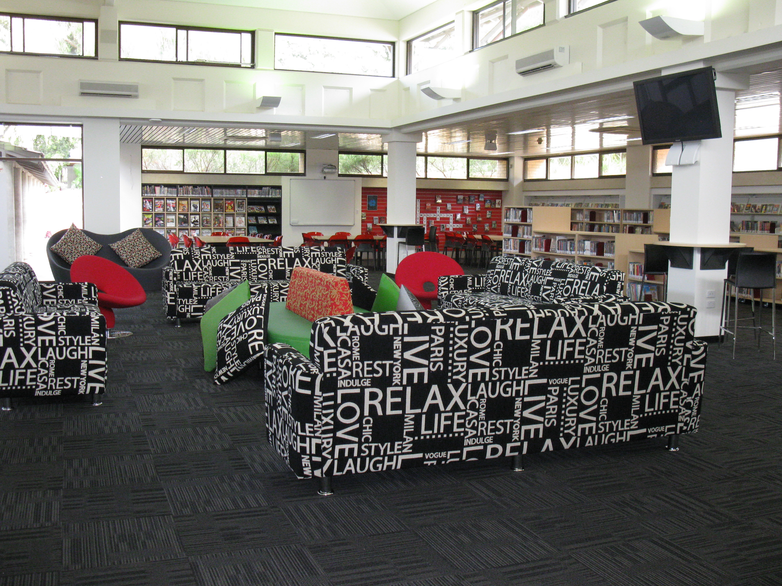  Senior school library, Scotch College
The Federal Government’s Inquiry into School Libraries and Teacher Librarians in Australian Schools (House of Representatives, 2011) found there are significant gaps between recommended standards and realities. Since there are no mandatory standards for school libraries or the employment of teacher librarians in most states, provision and staffing levels vary greatly between schools, States and education systems.  So where does your school library fit? Does your school even have a library? Is there a teacher librarian employed in your school? How does your school rate on the NAPLAN literacy tests?  NSW has mandated that all schools must have a teacher librarian. Are your children being disadvantaged because there is no information specialist to find the right learning resources, conduct intensive reading programs and promote literature and reading at your school?  Are schools in Western Australia lagging behind, especially government sector schools which have suffered huge budget and staffing cuts in 2014, with more of the same forecast for 2015? These cuts are occurring in spite of a population increase in WA, the closure of schools in rural areas and the move towards the creation of super schools with populations of over 2000 students.  Considering how teacher librarians can contribute to the teaching and learning process and the development of curriculum programs across the school, should your school be without a teacher librarian?  Parent Power  These are some of the questions that parents need to be asking to ensure their children are provided with equal opportunity to grow and succeed at school. Every child is entitled to a good education and government schools should be offering equal opportunities for all students.  Parents are a significant and important force in education. Parents can make a difference to government decisions by making sure their voices are heard and influencing their Principals, who are increasingly responsible for the make-up of their staff.  WASLA is always available to parent groups to provide extra information and advice. For more information and links please go to the WASLA website at http://www.wasla.asn.au/  Reading Programs  Schools can offer a variety of programs to increase student reading and literacy levels. Whole school programs that include teachers, administration and even the Principal, as well as parents provide the best role modeling. |  |  |  | During these programs everyone in the school participates in the program by keeping a reading log and or reading at a designated time every day. Programs such as RIBIT (Read in Bed It’s Teriffic) include reading logs, bookmarks, fiction lists and rewards. These can be further extended to include ebooks, reviewer blogs, digital teacher reader boards and collaborative stories.  DEAR (Drop Everything and Read) is a program where 15 minutes every day is set aside for everyone in the school (from the Principal, administrative staff, teachers and students) to stop what they are doing and read.  Role modeling is an important part of reading and literacy. While research tells us that speaking appears to be wired into our genes, this is not the case with reading and literacy.  There are two steps to reading. Firstly, being able to read the words on the page. Secondly, being able to understand, comprehend or make meaning from what you read. The more you read and engage your imagination as with fiction, the higher your levels of comprehension.  Whole school reading programs places everyone onto the same page and sends a message to students that reading is vitally important. Parents who also read to their children and who are seen to be reading by their children, also send important messages about the value of literacy.  Teacher librarians (TLs) select fiction and nonfiction resources for the school library. These resources may be digital or in print and part of the role of the TL is to promote reading and literacy outcomes for students.  Below are some other events/programs designed to encourage the development of reading and literacy:  - The Children’s Book Council Awards  - West Australian Young Readers Book Award  - Western Australian Premier’s Book Awards  Things to do online to enhance reading, writing and literacy skills:  - The GiggleIT Project  - Book Raps  - National Simultaneous Storytime  Check out your local public library or bookshop. These venues often have weekday and weekend activities that include storytime, technology help and study sessions. The Western Australian State Library also has a wonderful activity centre on the second floor (adults must be accompanied by a child) that includes a workshop venue for school children. There is also a technology centre on the ground floor. Become an active participant in your child’s education  Dr Barbara Combes, President WASLA

