WASLA RELIEF REGISTER 2016

First name: Surname:

Postal Address:_______________________________________________

Suburb:___________________ Postcode:________________________

Phone:___________________ Mobile:__________________________
Email:______________________________________________________

Classification: Teacher Librarian Library Technician
Resource Teacher Library Officer
Librarian

Qualifications:

Area preference:

School preference: Primary Secondary K-12
Education Dept. Number:

TRB #

Working With Children Check:

Yes
No

Automation System Experience:
Infiniti
Informatif
Athena
Destiny
Alice
AIMS
Films
E-Library
V-Library
AMLIB
Access-It
Bookmark
Oliver
Days of the week available:
Monday
Tuesday
Wednesday
Thursday
Friday
Terms Available:
Term 1
Term 2
Term 3
Term 4
Smart Library
Other:

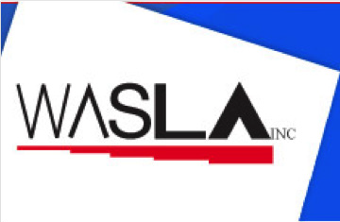
WASLA maintains a relief register of Teacher Librarians, Library Technicians and Library Officers available to do relief work in both Government and Independent schools in Western Australia.

The register is maintained by a committee member of WASLA and is provided to schools who require relief personnel for their school libraries. People interested in being included on the register, need to complete the Relief Register form. Those schools, who are seeking relief personnel for their school libraries, are able to obtain a copy of the list from WASLA which provides a list of names and contact numbers of people who fulfil the criteria. The school will then make contact with people from that list.

It is essential that all people wishing to join the relief register have a Working with Children Check. All Teacher Librarians must be registered with the Teacher Registration Board.

ENQUIRIES: email wasla@wasla.asn.au
WESTERN AUSTRALIAN SCHOOL LIBRARY ASSOCIATION PO BOX 1272 WEST PERTH WA 6872
ABN 14 788 316 426

